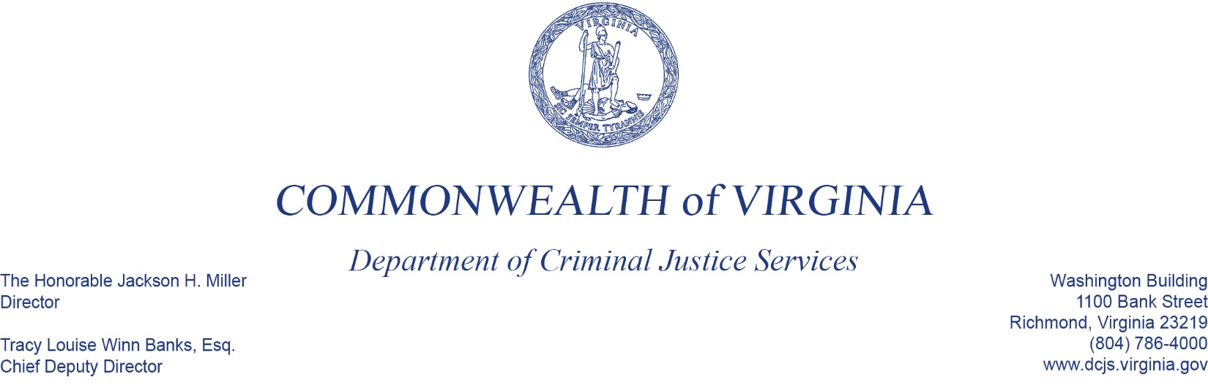
To: Criminal Justice Services Board Grants Committee
From: Laurel Marks, Manager, Juvenile and Child Welfare
Date: June 2, 2022
Re: FY23 Child Advocacy Center Grant Program - VDSS

For many years, DCJS has awarded VOCA funds to the Virginia Department of Social Services (VDSS) to supplement the state funding appropriated in VDSS’ budget. While this award goes to VDSS for direct support to CAC programs, we continue to have monitoring responsibility and we work collaboratively with VDSS in their support of CACs.

With this award, 19 local CAC programs will receive funding to support child and youth victims of crime.

A Children's Advocacy Center (CAC) is a child-focused, facility-based program where representatives from many disciplines meet to discuss and make decisions about investigation, treatment, intervention, and prosecution of child abuse cases. The main priority of a CAC is to provide a child victim with services for treatment and healing while working with key stakeholders to prevent further victimization of children.

The request before you is for $4,430,582.00 in federal Victims of Crime Act funds. No match is required for FY23.

